Practical no.1
Code:
studentname =input("enter your student name:")
print(" student name is",studentname)

age =int(input("enter your age:"))
print("your age is:",age)

collagename =(input("enter your collage name:"))
print("your collage name is:",collagename)

studentprn = (input("enter student prn: "))
print("student prn is:",studentprn)

studentemail = (input("enter student email id"))
print("student email id is :",studentemail)

Output:
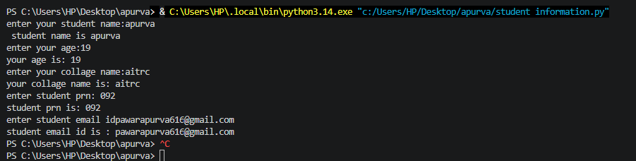

Exercise
Que1: develop a program that accept a student’s marks for three different subject .calculate their total and average , and print a final scorecard with the rounded to two decimal places
Code:
name = (input("enter student name"))
s1 = float(input("enter subject 1 marks :"))
s2 = float(input("enter subject 2 marks:"))
s3 = float(input("enter subject 3 marks :"))

subject = s1 + s2 +s3
average = subject/3

print("_____student score card______")
print("student name:",name)
print("subject1:",s1)
print("subject2:",s2)
print("subject3:",s3)
print("total marks:",subject)
print("average marks:",average)

Output:
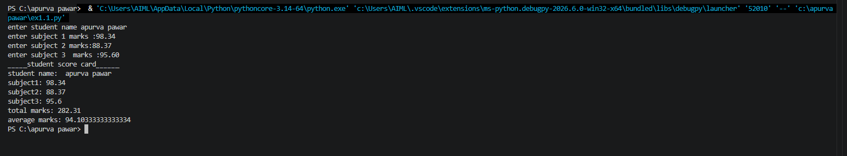

Que 2 : create a simple profile generator that takes an employee name role and monthly salary and prints out a formatted text-based employee identity card.

Code:
name = (input("enter employee name:"))
role = (input("enter emplyee role:"))
salary = int(input("enter emplyee salary:"))

print("____emplyee salary card____")
print("emplyee name",name)
print("emplyee role",role)
print("emplyee salary:",salary)
output: 